**DATA MODELLING**

1. **Landing Table :** The steps of creating Landing table are:

* Open MDM HUB Console.
* Acquire Write Lock by Write Lock -> Acquire Lock.
* Go to Schema then select Landing table and right click on Landing table and select Add item:

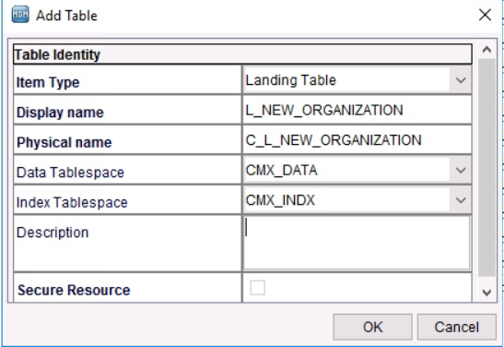

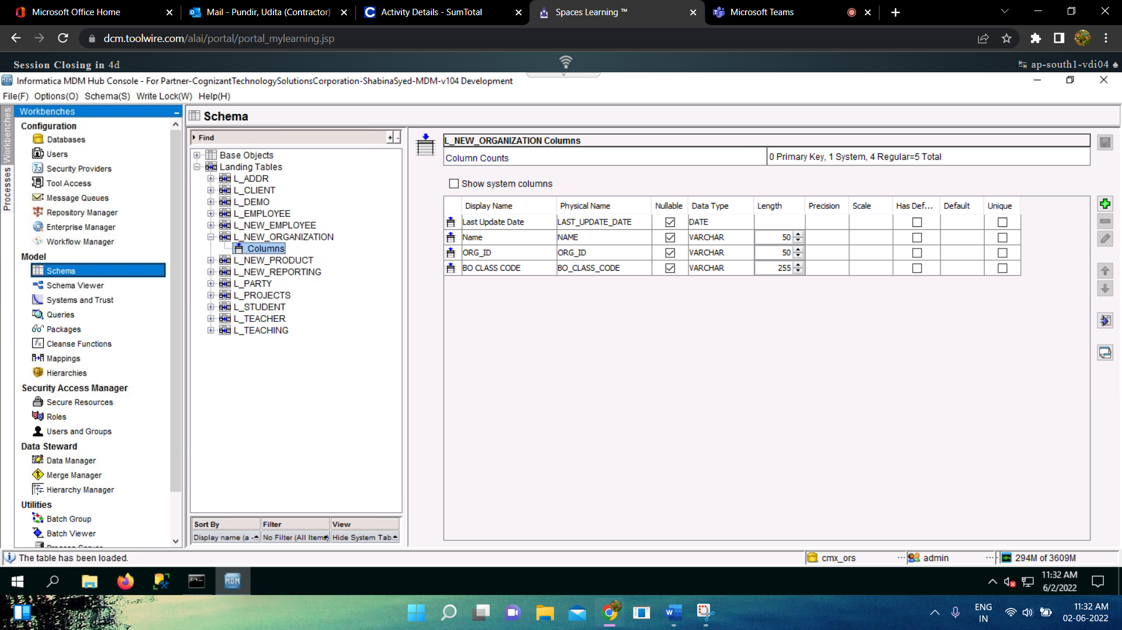

* Like this we’ll create Landing table as per our requirements . I have created other landing table **: L_NEW_EMPLOYEE, L_NEW_PRODUCT, L_NEW_REPORTING.**

1. **BASE OBJECT TABLE:** The steps of creating Base Object table are:
   * + Acquire Write Lock by Write Lock -> Acquire Lock.
     + Go To Schema then select Base Object table and right click on Base Object table and select Add item:

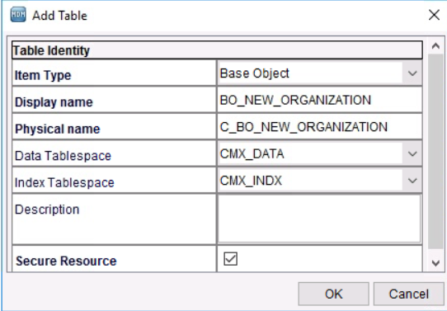

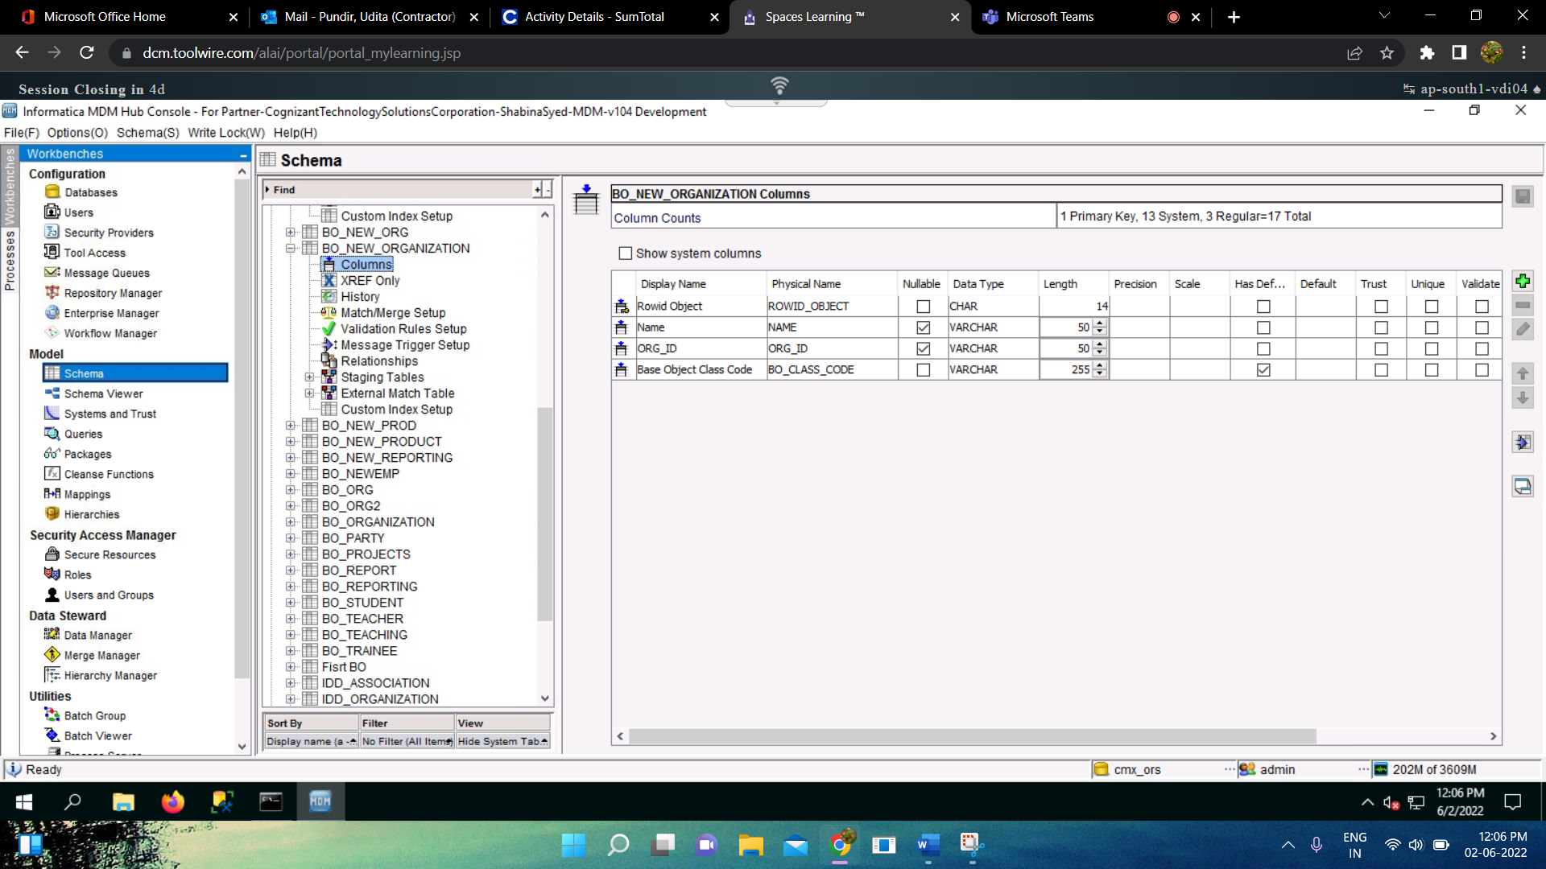

* + - Like this we’ll create Base Object Table as per the business requirements, I have created other landing table **: BO_NEW_EMPLOYEE, BO_NEW_PRODUCT, BO_NEW_REPORTING, BO_NEW_ASSOCIATION.**

1. **STAGING TABLE:** The steps of creating Staging Table are :
   * + Inside each Base Object Table we have Staging Tables under which we’ll create Staging table:

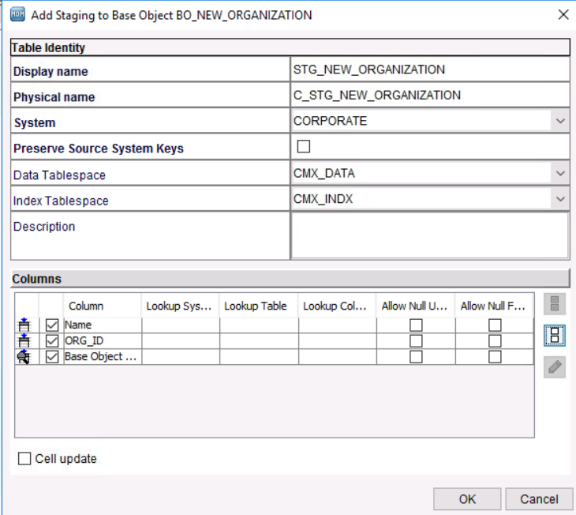

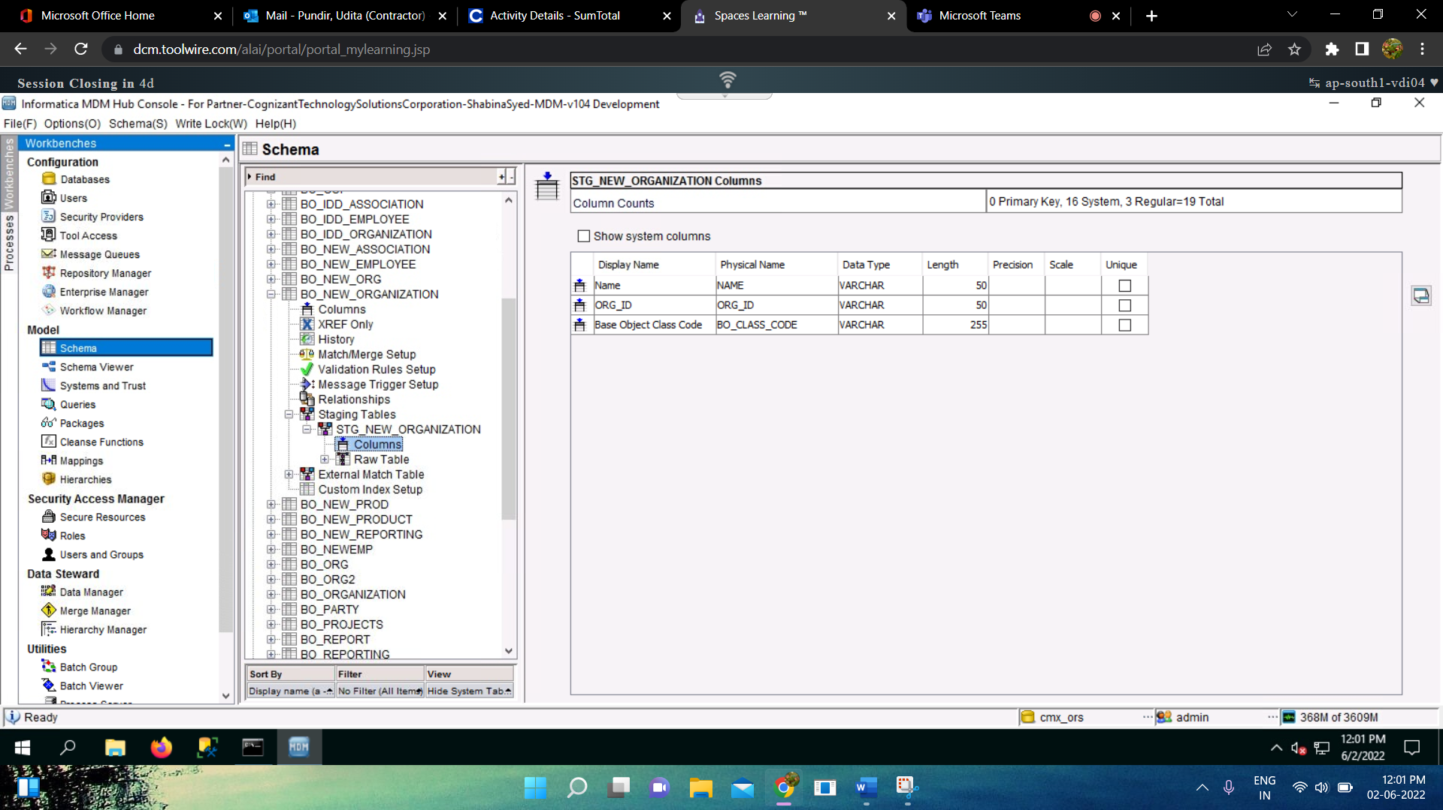

* Like these we’ll create Staging Table for each Base Object Table, I have created other Staging Table: **STG_NEW_EMPLOYEE, STG_NEW_PRODUCT, STG_NEW_ASSOCIATION, STG_NEW_REPORTING.**

1. **CLEANSE FUNCTION:** The steps of creating Cleanse Function are :
   * + Go To Cleanse Function under Model in the MDM HUB.
     + Acquire Write lock by Write Lock -> Acquire lock.
     + Select Companies and right click and select Add Cleanse List :

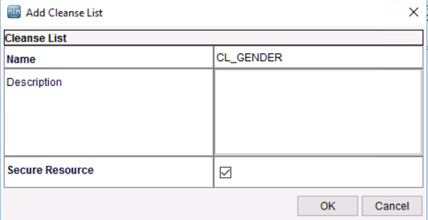

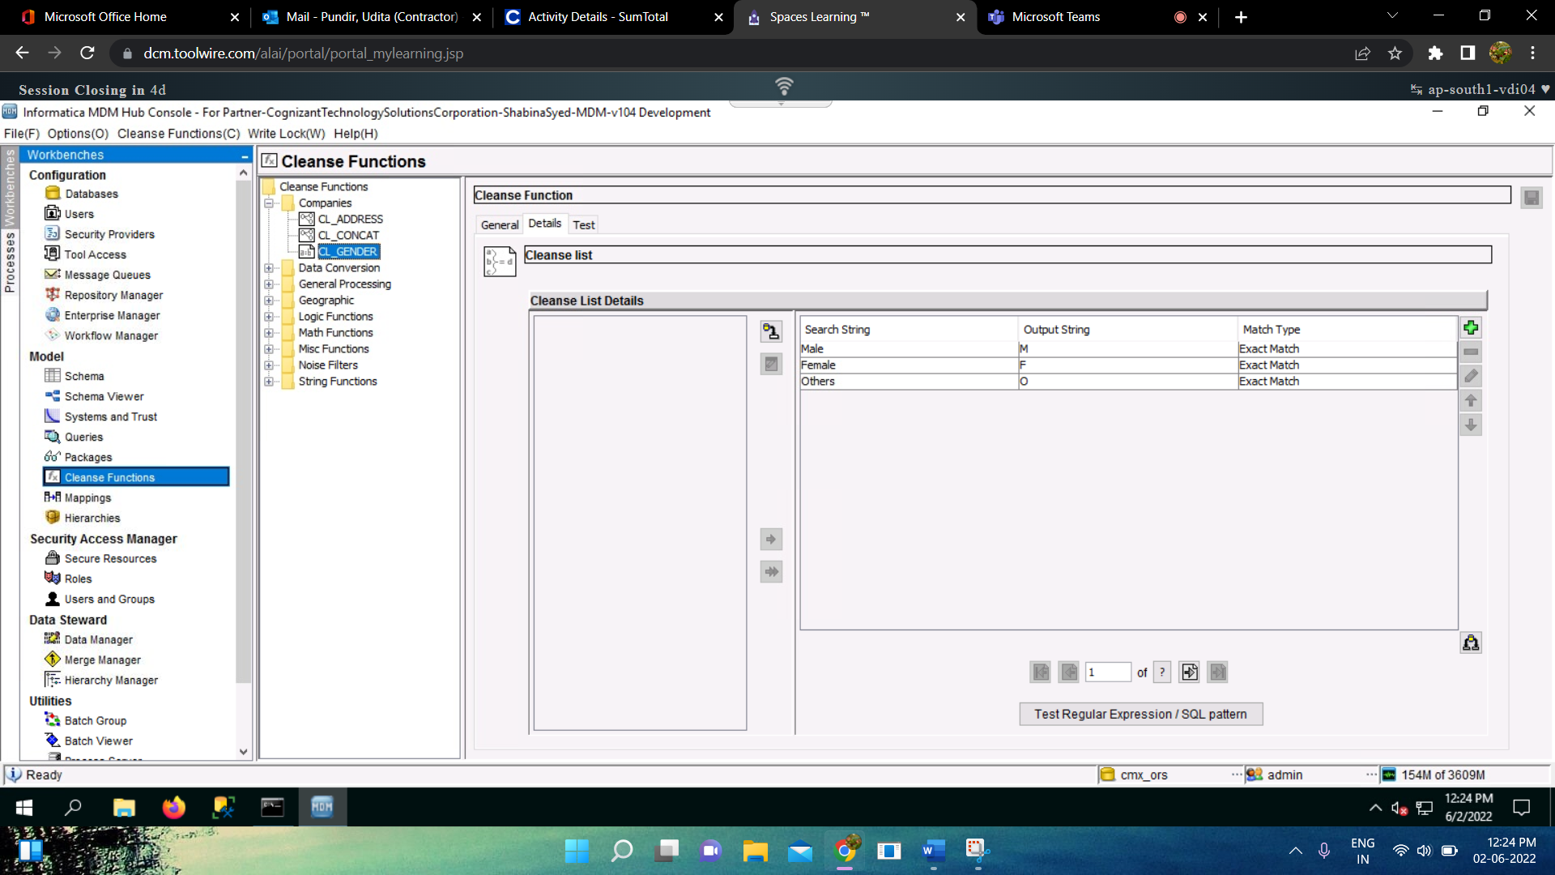

1. **MAPPINGS :** The steps of creating Mappings are :
   * + Go To Mappings under Model.
     + Go to Mappings -> Add Mapping.

